RingU

ProjectURL: http://ringu.mixedrealitylab.org

What is it?
With the Mini-Hug Ring you can give your boyfriend, girlfriend, or best friend a remote hug no matter how far you are from each other.

Anywhere you are, just hug the ring on your finger and at the same moment your significant other will feel that hug. For that very instant, you’ll feel each other’s warm presence.

It’s the world’s first tele-hug ring.
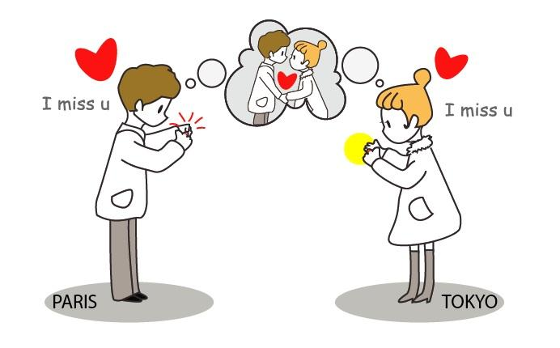
Who is it for?
For anyone in a relationship, romantic, platonic or by blood, age 8 to 88, who sometimes during the day cares to share their warm feelings but cannot be together because they are busy. With RingU, you’ll always be able to share your feelings with your friends, family, or loved one.

Why RingU?
You can always text your beloved partner, but it will never replace your sense of touch. Research has shown that empathetic communication strengthens relationships.

How does it work?
“Hugging” the ring by one person transmits the touch sense digitally to the other ring which replicates the sensation.
Using Bluetooth 4.0 the ring communicates with your smartphone which transmits the touch message over the internet.
To pair two rings all you need to do it bring them together to trigger its powers, or, if they are remote - use the complementary mobile app. 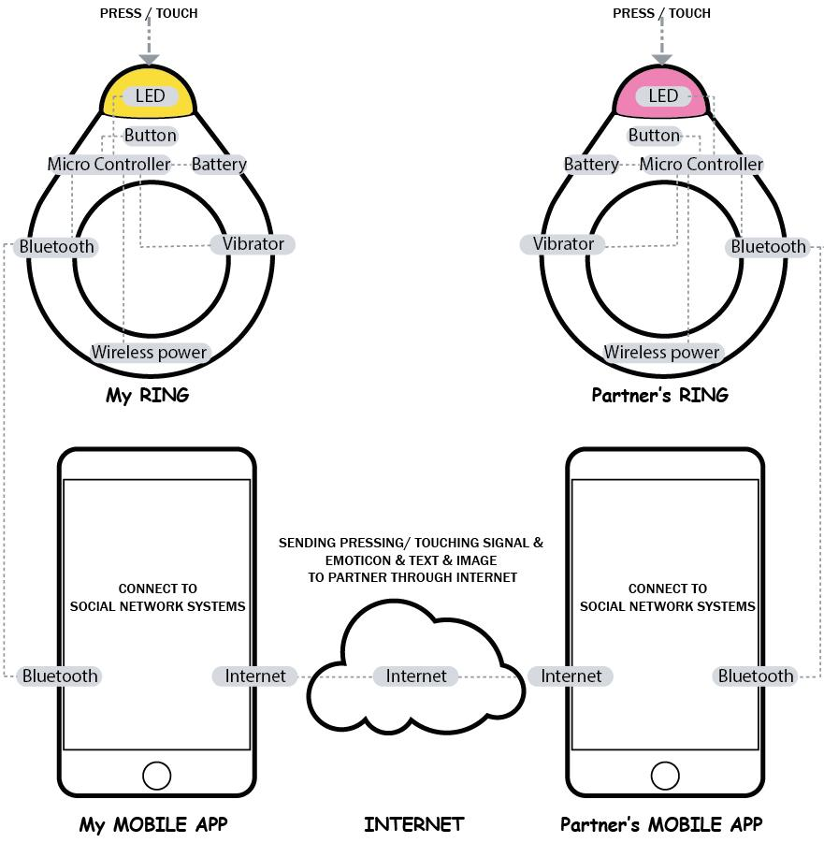

The ring supports 3 types of hugs: a Mini-Hug, an Intense Hug, and an Urgent Hug (short squeeze, long squeeze and a series of hugs in a row - respectively)

User can also set their partner’s ring led color. There are 5 different colors (green, blue, yellow, red, orange) and user can set each of the color to a certain emotion.

What does the RingU application do?

The ring comes with a corresponding private social network for two where you can send corresponding messages, photos, videos, together with your physical ring hugging. It also displays the time, date, and location of all your sent and received hugs. The ring synchronizes with the social network app seamlessly.
It allows you to customize the functions of the ring, pair with with your ring of choice.
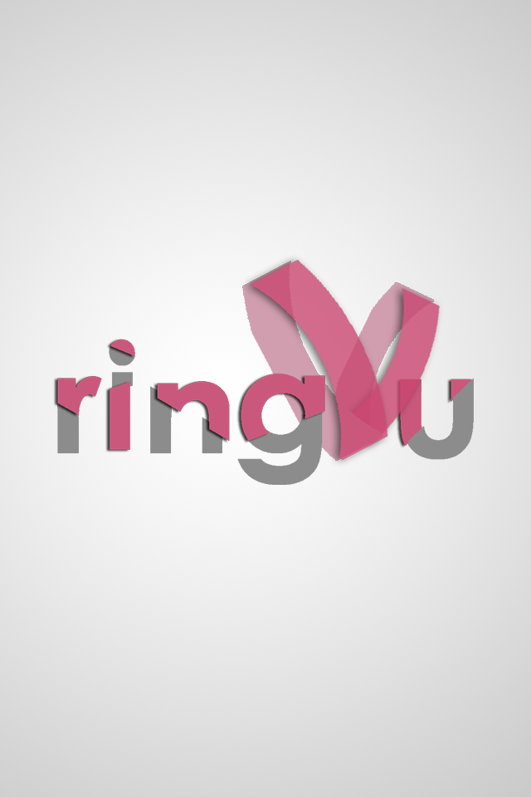
Splash Screen
This screen will be displayed as a welcome screen when user runs the
RingU application. It shows the main logo of RingU service
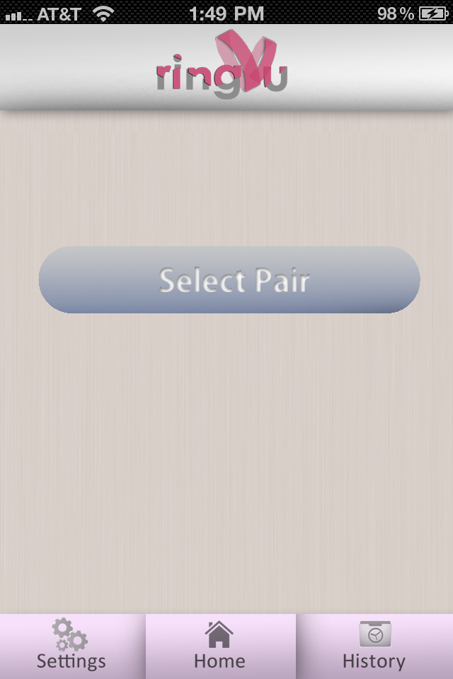
Select Pair Screen
This screen will be shown when user runs the application for the first
time. It will ask user to select pair to be connected with their ring. User
will have choice to select pair by connecting to facebook or by entering
the e-mail address of their partner. RingU app will do the rest to pair
both users and allow them to send emotion with RingU
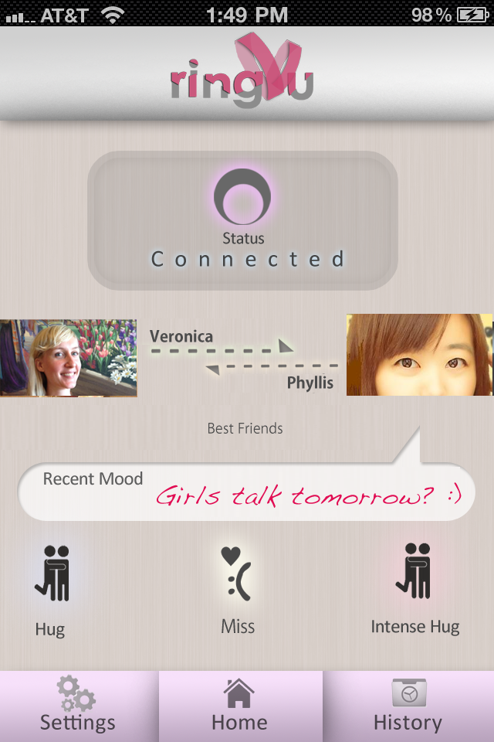
Main Screen
This will be the main screen in the app for user to interact with their
partner. Status icon shows whether both rings are connected. Pictures
of both users will be shown on the screen and their relationship will be
shown, which in this case : Best Friends. Recent mood of your partner is
also shown , so that user can easily understand what his/her partner
currently feeling. The emotion icons in the bottom part of the screen are
used to send the particular emotions to partner, such as hug, miss, or
intense hug.
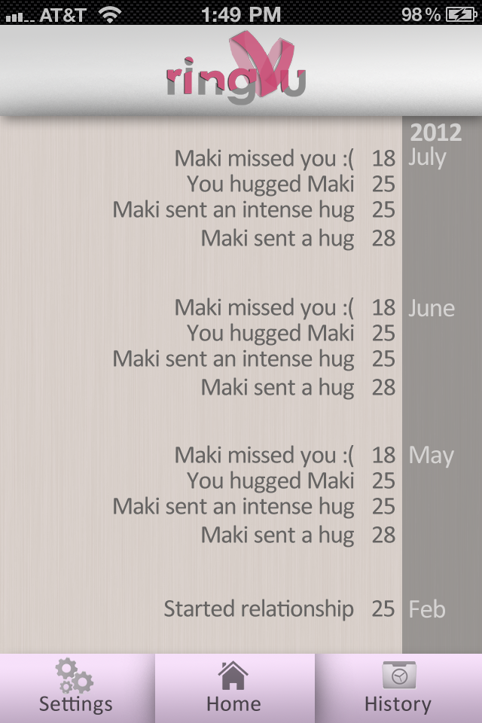
History Screen
This screen will show the log of interaction. Recent mood and emotions
sent between both users will be shown in timeline.

Is it a gadget or jewelry? What is it made of?
We think it’s both and much more!
It’s stylish and will look beautiful on your finger, and it is technically an accessory to your mobile phone - however think about it as a new form of remote empathetic communication.
The standard RingU is made of a textured plastic case.

Does it come in multiple colors?
You're part of the design process! Three colors options are already set: Arctic White, Jet Black and Violet Purple. If you back any of the color options, we'll email you a survey after the project closes so you can vote on a new, 4th, color option. Later on, we'll email you again asking which of the final color options you'd like to select. Even if you don't like the Voter's Choice, you'll be able to choose from White/Black/Purple.

Compatibility: iPhone 3GS, 4, 4S running iOS 5 or any iPod Touch with iOS 5 and above. selected Android phones will have compatibility in future.

Can I customize its appearance?
We are always open for feedback and ideas from the community and will periodically release new form factors.
We will also publish the 3D models, technical drawings, and software of the ring as creative commons, so hardware hackers can customize it and create new form factors and add functions on their own.

What are the luxury rings?
The luxury rings are true jewelry cast from 24 karat gold or silver, or diamond. It makes a great wedding, engagement, or anniversary ring!
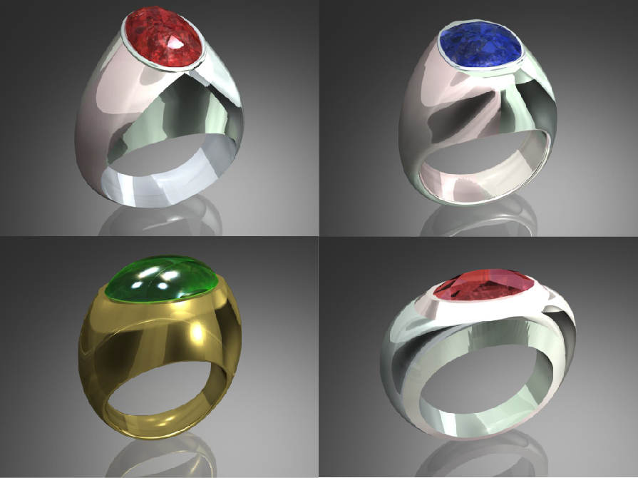

In what stage of development is it?
We have been working on similar empathetic communication devices for over 10 years. As seen in the video, RingU is in a working prototype stage.
With the your support we be able to bring the ring to fingers all over the world.

Your contribution will help fine tune the design, finish developing the iOS SDK, complete global Bluetooth certification, and the large component order.

When will it be released?
The first batch of rings will be ready for shipment 6 months from the moment the funding is successful.

Who’s behind the Mini-Hug ring?
Adrian David Cheok
YongSoon Choi
Jordan Tewell
Gilang Andi Pradana
Keijiro Abe

